
Project Report
AMERICAN INTERNATIONAL UNIVERSITY–BANGLADESH (AIUB)
FACULTY OF SCIENCE & TECHNOLOGY
SPRING 2025 - 2026

Computer Graphics
Section:
Group No: 08

Project Report on:
Multi-Scene OpenGL Simulation
Metro Rail Town | Rural Road | Amusement Park

Submitted to:
Mahamodul Hasan Mahadi
Lecturer, Department of Computer Science
American International University-Bangladesh
Submitted By:
Name | ID | CONTRIBUTION (%)
Fahim Abrar Bhuiyan | 23-53411-3 | 30%
Khondker Sadman Hossain | 24-56303-1 | 30%
Md Faisal Ahmed | 23-53695-3 | 30%
Safkat Khan | 22-46392-1 | 5%
Md Ridoyuzzaman | 22-47287-1 | 5%

Date of Submission: 19 May 2026
- Introduction
This project is a multi-scene interactive simulation developed using OpenGL (GLUT) and C++. It integrates three distinct real-world environments into a single executable window, allowing the user to seamlessly switch between scenes at runtime by pressing the X key. The three scenes represent: (1) the Dhaka MRT-6 Metro Elevated Rail Corridor, (2) a Rural Road with a traffic signal system, and (3) an Amusement Park with a ferris wheel, walking humans, and animated wildlife.
The project demonstrates practical application of fundamental Computer Graphics concepts including 2D geometric transformations, color blending, animation via timer callbacks, scene management, particle systems, and procedural drawing using OpenGL primitives.

- Objective
The objectives of this project are:
- To design and implement three visually distinct and animated 2D scenes using OpenGL/GLUT.
- To apply core Computer Graphics concepts such as transformations, color blending (alpha), and clipping.
- To implement a real-time animation system using glutTimerFunc for smooth motion.
- To develop a scene-switching mechanism using a single shared GLUT window.
- To simulate realistic behaviors including traffic signal logic, particle rain/snow, flocking birds, and a rotating ferris wheel.
- To handle keyboard-driven interactivity to toggle weather, day/night, traffic, and animation states.

- Tools and Technologies Used
Tool / Technology | Purpose
C++ (C++11) | Primary programming language
OpenGL (GL/gl.h) | 2D rendering API — primitives, transformations, blending
GLUT / FreeGLUT | Window management, input callbacks, timer-based animation
GLU (glu.h) | Supplementary utility functions
Windows.h | Windows OS compatibility header
Visual Studio / MinGW g++ | Compilation and linking environment
math.h / cmath | Trigonometric functions for circles, arcs, sine waves
cstdlib / ctime | Random number generation for particles and stalls

- System Description
The system is structured as a single OpenGL application that manages three completely independent scenes through a global scene index (currentScene). All three scenes share one GLUT window with double-buffered rendering. Pressing X cycles currentScene from 1 to 2 to 3 and back to 1. A single 16 ms timer callback (update()) dispatches to the active scene's update function each frame, ensuring smooth 60 fps animation.

  - Scene 1 — Rural Road Traffic Scene
This scene depicts a rural town road with two lanes of opposing traffic separated by a central divider. Three cars travel right-to-left in the lower lane and three cars travel left-to-right in the upper lane. A working traffic signal at x = –0.625 governs lower-lane cars: on red or yellow, approaching cars decelerate and stop precisely at the stop line without overshooting. Cars that have already crossed the signal continue freely. Upper-lane (opposite direction) cars stop before the signal if approaching, but pass through unimpeded once they have crossed it. The background includes houses, a hospital with a red cross, a large tree, zebra crossings, lamp posts, animated birds with flapping wings, a drifting cloud and sun/moon cycle.

  - Scene 2 — Amusement Park
The park scene features a richly detailed outdoor environment. A gradient sky transitions smoothly from light blue at the horizon to deep blue at the top, with a glowing sun or crescent moon depending on the day/night state. Clouds drift slowly across the sky. The ground is layered grass with a dark soil strip. A winding S-curve gravel pathway with embedded pebble stones runs through the park. A rotating ferris wheel (nagordola) with 8 colourful cabins, cabin windows, arched roofs, and hanging rods spins continuously. Three human figures with animated walking legs, swinging arms, and facial features wander freely, bouncing off the park boundaries. Lamp posts emit warm glow cones at night. Flowering trees, scattered flowers, benches, and picket fences complete the environment.

  - Scene 3 — Metro Rail Town
This scene simulates the Dhaka MRT-6 metro line. It features an animated metro train travelling along an elevated viaduct supported by concrete pillars. The background contains 11 procedurally drawn skyscrapers with individually randomized lit/unlit windows, blinking aviation lights, and radio antennas. Below the viaduct, market stalls with hanging awnings and vendor products are drawn. Three traffic lanes on the road below carry animated cars. The scene supports full weather simulation: rain (particle system), snow (drifting flakes), fog (alpha overlay), night/day toggle, city-wide light switch, and adjustable metro speed.

5. Implementation Details
5.1 Initialization
The main() function performs all initialization before entering the GLUT event loop:
- initRain(), initSnow(), initStars() — fill particle arrays with random positions and speeds.
- initMetroCars() — assign random positions, speeds, and colours to 14 road vehicles.
- initFlicker() — randomize 12×16×8 boolean array for building window lit/dark states.
- fv_initCars() — initialize 6 rural lane vehicles with staggered x positions.
- srand(time(nullptr)) — seed the random number generator for varied results each run.
- glutInitDisplayMode(GLUT_DOUBLE | GLUT_RGB) enable double buffering to eliminate flicker.
- glutTimerFunc(60, update, 0) — start the single 16 ms animation loop.

5.2 Display Function
The project is implemented by calling different functions repeatedly. In some cases, transformations such as translation and scaling are applied together while calling the functions to position and resize objects properly within the scene. The unified display() callback checks currentScene and delegates to displayScene1(), displayScene2(), or displayScene3(). Each scene function clears the buffer, draws all elements in painter's-algorithm order (background first, foreground last), renders a HUD overlay with key hints, and calls glutSwapBuffers() to present the finished frame. Example:
if (currentScene == 1)
{
displayFahim();
}
else if (currentScene == 2)
{
displaySadman2();
}
else if (currentScene == 3)
{
displayfaisal();
}
5.3 Timer Function
A single update() function is registered with glutTimerFunc(16, update, 0) and re-registers itself each call. It advances all state variables for the active scene and calls glutPostRedisplay() to trigger a redraw. State that is updated includes: metro train x position, rain/snow particle y positions, fog density interpolation, car x positions, sun rotation angle, cloud offset, ferris wheel angle, bird x position, bird wing flap counter, and human walking angle.
5.4 Drawing Techniques
The following core OpenGL drawing techniques are used throughout the project:
- GL_TRIANGLE_FAN — used for all circles and ellipses (sun, moon, wheels, heads, flowers, glow halos).
- GL_TRIANGLE_STRIP — used for the ferris wheel outer ring (efficient concentric ring).
- GL_QUADS / glRectf — buildings, road layers, car bodies, windows, bench slats, fence rails.
- GL_POLYGON — car outlines (curved body shapes), pathway, human body parts, cabin roofs.
- GL_LINES — train rails, lamp post arms, ferris wheel spokes, rain streaks, bird outlines.
- GL_BLEND + GL_SRC_ALPHA_ONE_MINUS_SRC_ALPHA — alpha transparency for glow halos, fog overlay, rain streaks, drop shadows.
- glPushMatrix / glPopMatrix — isolate coordinate transformations per object.
- glTranslatef / glRotatef / glScalef — position, rotate, and size objects in world space.
- glRasterPos2f + glutBitmapCharacter — render HUD text and destination signs.
5.5 Alpha Blending & Glow Effects
Glow effects (sun halo, lamp posts, train headlights) are achieved by drawing multiple concentric circles with decreasing alpha values using GL_BLEND. The headlight cone uses GL_TRIANGLE_FAN where the center vertex has alpha 0.38 and outer vertices have alpha 0.0, creating a physically plausible light cone that fades at the edges.

5.6 Matrix Stack Usage
Every movable or rotatable object is wrapped in glPushMatrix() / glPopMatrix() so transforms do not accumulate across objects. The ferris wheel rotation is applied by translating to the wheel center, rotating, then translating back before drawing all wheel geometry — a standard rotation-about-a-point technique.
glPushMatrix();
glTranslatef(centerX, centerY, 0);
glRotatef(wheelAngle, 0, 0, 1);
glTranslatef(-centerX, -centerY, 0);
// draw ring, spokes, cabins ...
glPopMatrix();
5.7 Particle Systems
Rain and snow are implemented as simple particle systems:
- Each particle has float x, y, speed.
- Every frame, y is decremented by speed (multiplied by rainSpeedMult for rain). Snow also drifts sideways using sinf(frameCount + phase).
- When a particle’s y drops below −1.0 (off-screen bottom), it respawns at y = 1.0 with a new random x.
- Rain is drawn as short diagonal GL_LINES with low alpha. Snow is drawn as small circles.

- Algorithm (Step-by-Step)
5.1 Main Program Flow
- Step 1: Initialize all particle arrays, car arrays, and window flicker states.
- Step 2: Create GLUT window with double buffering.
- Step 3: Register display(), keyboard(), and update() callbacks.
- Step 4: Start glutTimerFunc(16, update, 0).
- Step 5: Enter glutMainLoop() — event loop runs forever.

5.2 Frame Update Algorithm (update())
- Step 1: Check currentScene. Call the matching updateSceneN() function.
- Step 2 (Scene 0): Advance metroX, cloudOff, sunAngle. Move rain/snow particles down. Interpolate fogDensity. Move road cars.
- Step 2 (Scene 1): If animation flag set: move sun/cloud, move birds, flap wings, move plane. For each car: check red/yellow + stop-line logic → stop or move. Check car-following gap → slow or normal speed.
- Step 2 (Scene 2): Decrement wheelAngle (spin ferris wheel). Oscillate walkAngle (leg swing). Drift cloudX. Move each human with boundary bounce.
- Step 3: Call glutPostRedisplay().
- Step 4: Re-register glutTimerFunc(16, update, 0) for next frame.

5.3 Scene Switching Algorithm
- User presses X key.
- keyboard() computes: currentScene = (currentScene + 1) % 3
- glutPostRedisplay() triggers a redraw.
- display() reads currentScene and calls the matching displaySceneN().
- The update() timer continues running the active scene’s update function.

7. Output Description
7.1. Scene 1 — Rural Road Traffic Output
This scene tries to represent a rural city environment. In the upper part of the screen, there are houses, tall buildings, distant skyscrapers, and a hospital. In front of the buildings, there are lamp posts and a tree. In the sky, there is an airplane and five flying birds with animated wings. During the daytime, a white cloud can be seen in the sky. The sun slowly rises and sets. At night, two lamp posts spread light on the road, stars twinkle beautifully in the sky, and the moon appears. The dark night sky and lamp post lights make the city road look realistic.
In the lower half of the screen, a road is shown where five human characters are walking around on the footpath. On the main road, six cars move automatically. There are two lanes: the upper lane moves from left to right, and the lower lane moves from right to left. Each lane contains three cars, and they always stay in their own lane. When one car comes too close behind another car, it slows down and follows the front car. At that time, the backlights of the cars glow to show that they are moving slowly in traffic.
There is also a zebra crossing and a traffic light system with red, yellow, and green lights. When the red light turns on, the cars stop before the zebra crossing and do not cross it. Cars on the other parts of the road continue moving normally. When the green light turns on, the cars cross the zebra crossing and continue driving. During the yellow light, the cars move slowly while crossing that area.
At night, the headlights of the cars spread light on the road in front of them. One human character crosses the road only when the traffic light is red. During green and yellow lights, the person does not cross the road. When the red light turns on again, the person returns to the previous side of the road. The other people continue walking on the footpath.
This scene also includes a rain effect. The speed of the rain can be increased or decreased gradually.
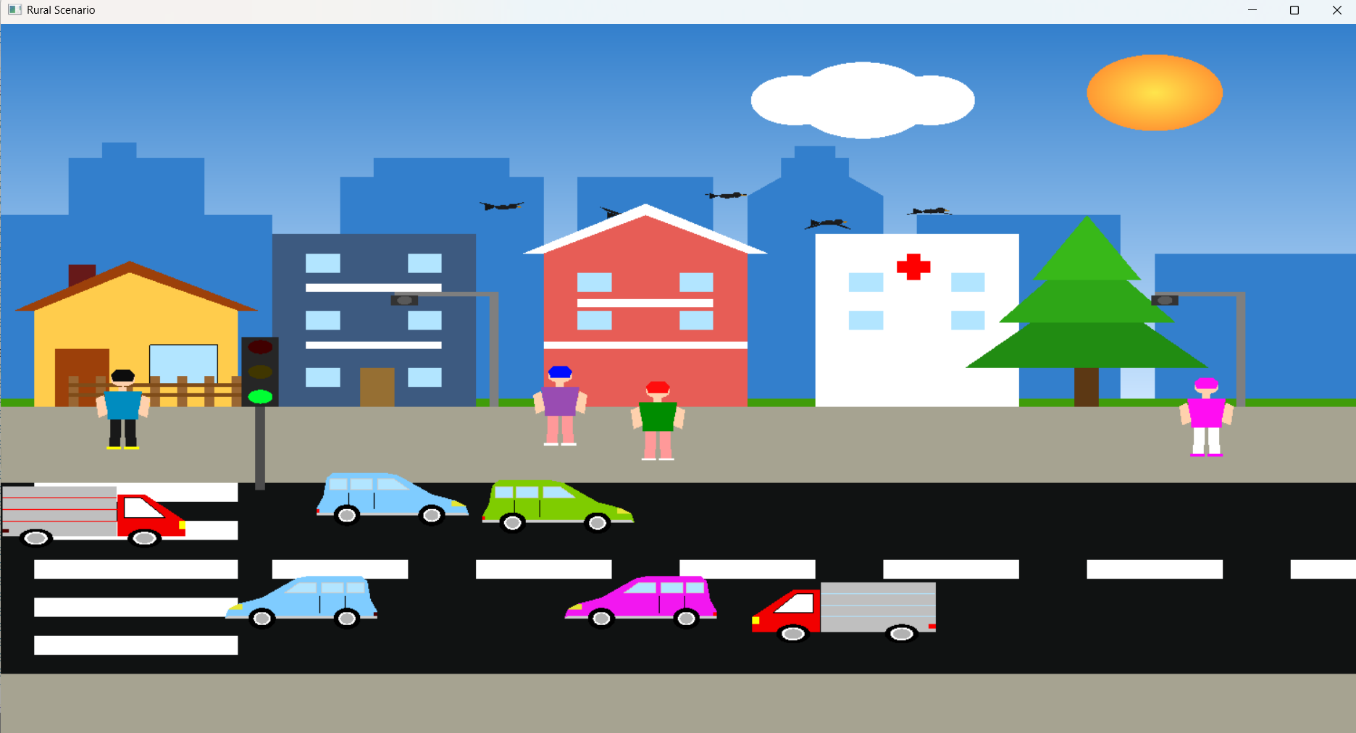
Fig 1: simple live scenario of Rural Road Traffic Output in Day Scenario.
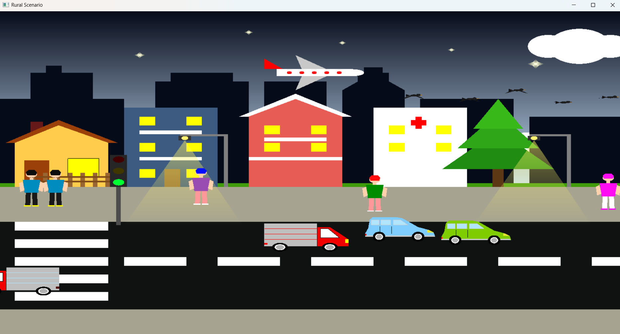
Fig 2: simple live scenario of Rural Road Traffic Output in Night Scenario.

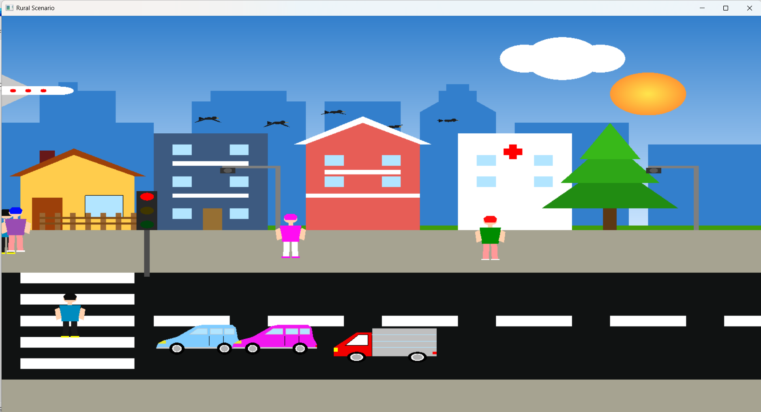
Fig 3: Rural Road Traffic Output in Red light on Scenario.

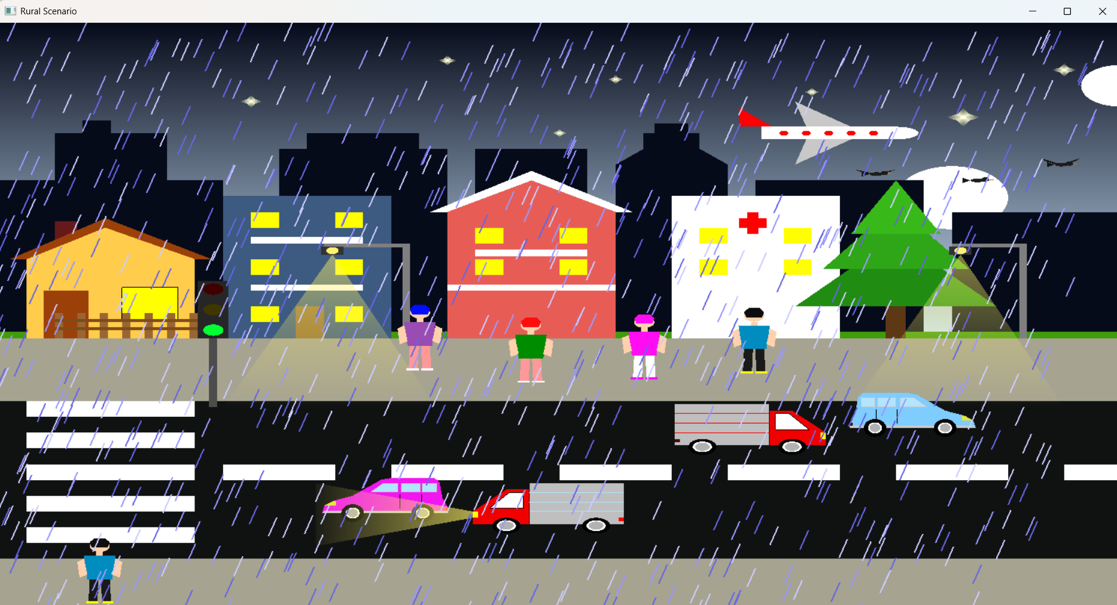
Fig 4: simple live scenario of Rural Road Traffic Output in Rain Scenario.

7.2. Scene 2 — Amusement Park Output
In this scene, a green field is shown with ten trees of different shapes and sizes. Some of the trees contain colorful flowers such as white, pink, red, and purple flowers. White, red, and pink flowers are also scattered around the green field, making the park look beautiful and natural.
There are two benches in the park. Each bench is divided into two parts. The upper part looks like a backrest for leaning, while the lower part is used for sitting. The legs of the benches are also visible below them. Around some trees, grass and small stones can be seen, which adds more realistic detail to the environment.
A curved pathway is shown in the middle of the park, which looks like a soil or dirt road. There is also a ferris wheel in the park that rotates continuously. The ferris wheel contains eight colorful passenger cabins for riding.
At the far end of the park, a fence surrounds the area. In the sky, clouds move slowly while the sun remains fixed during the daytime. At night, the sky becomes dark and stars twinkle beautifully.
There are also three human characters in the park. They move freely around the field and walk in different areas of the park on their own.
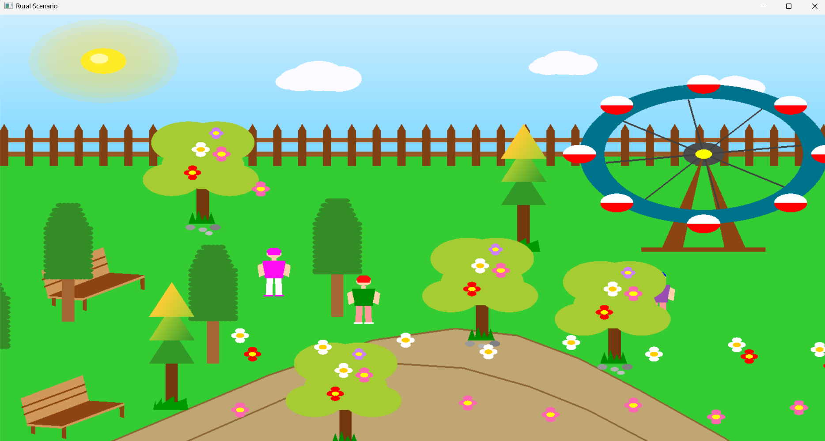
Fig 5: simple live scenario of Amusement Park Output in Day light Scenario.

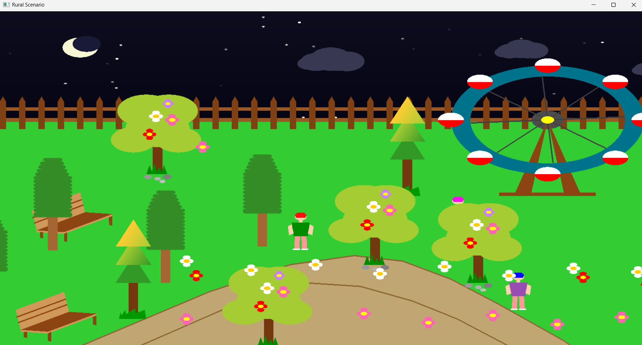
Fig 6: simple live scenario of Amusement Park Output in Night Scenario.

7.3. Scene 3 — Metro Rail Town Output
This scene represents a modern metro city environment. In the background, there are eleven tall buildings. Some red lights are placed on the rooftops of the buildings, which glow at night. During nighttime, some windows of the buildings light up while others remain dark, creating a realistic city atmosphere.
In the sky, several clouds can be seen. During the daytime, the sun spreads light across the sky, while at night the moon appears and lights up the dark sky. Numerous stars twinkle beautifully during the night.
Below the buildings, a metro rail line and metro station are shown. Two metro trains move on the railway track. Each metro contains five compartments. One metro train has “MOTIJHEEL” written on the front window and moves from left to right. Another metro train has “UTTARA N” written on the front and moves from right to left on the same railway track. In the middle of the station, the text “MOTIJHEEL MRT 6” is displayed.
The speed of the metro can be increased or decreased. The minimum speed is zero, and the maximum speed is 16 kilometers per hour. The current speed is displayed on the screen, and the whole system can be controlled using the keyboard.
Under the metro rail, several shops are placed beside the road. The shops are labeled FOOD, BOOKS, FRUIT, VEG, CLOTH, PHONE, SPICE, and TOYS. Each shop has a different color. In front of the shops, small trees can be seen, with two different types of trees placed around the area. There are also seven lamp posts that spread light on the road during nighttime. The shops also emit light in front of them at night.
The road is divided into two lanes where many colorful cars move continuously. At night, the cars spread light from their front headlights. Vehicles in both lanes move in opposite directions, from left to right and right to left. At the end of the screen, several small trees are placed beside the road. A total of six trees with two different designs are shown in that area.
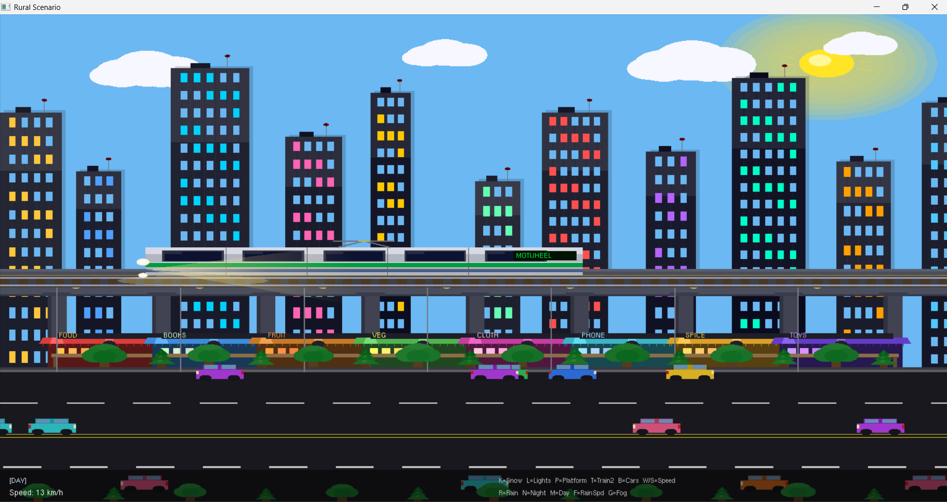
Fig 7: simple live scenario of Metro Rail Town Output in Day light Scenario with MOTIJHEEL Metrorail.
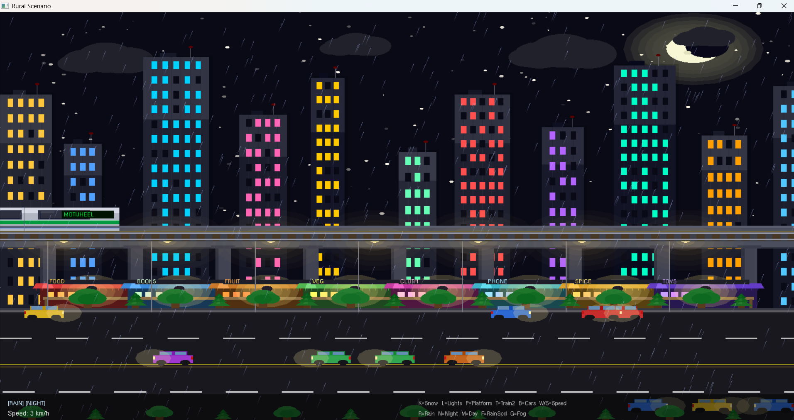
Fig 8: Metro Rail Town Output in Night with streetlamp light Scenario with rain drops.

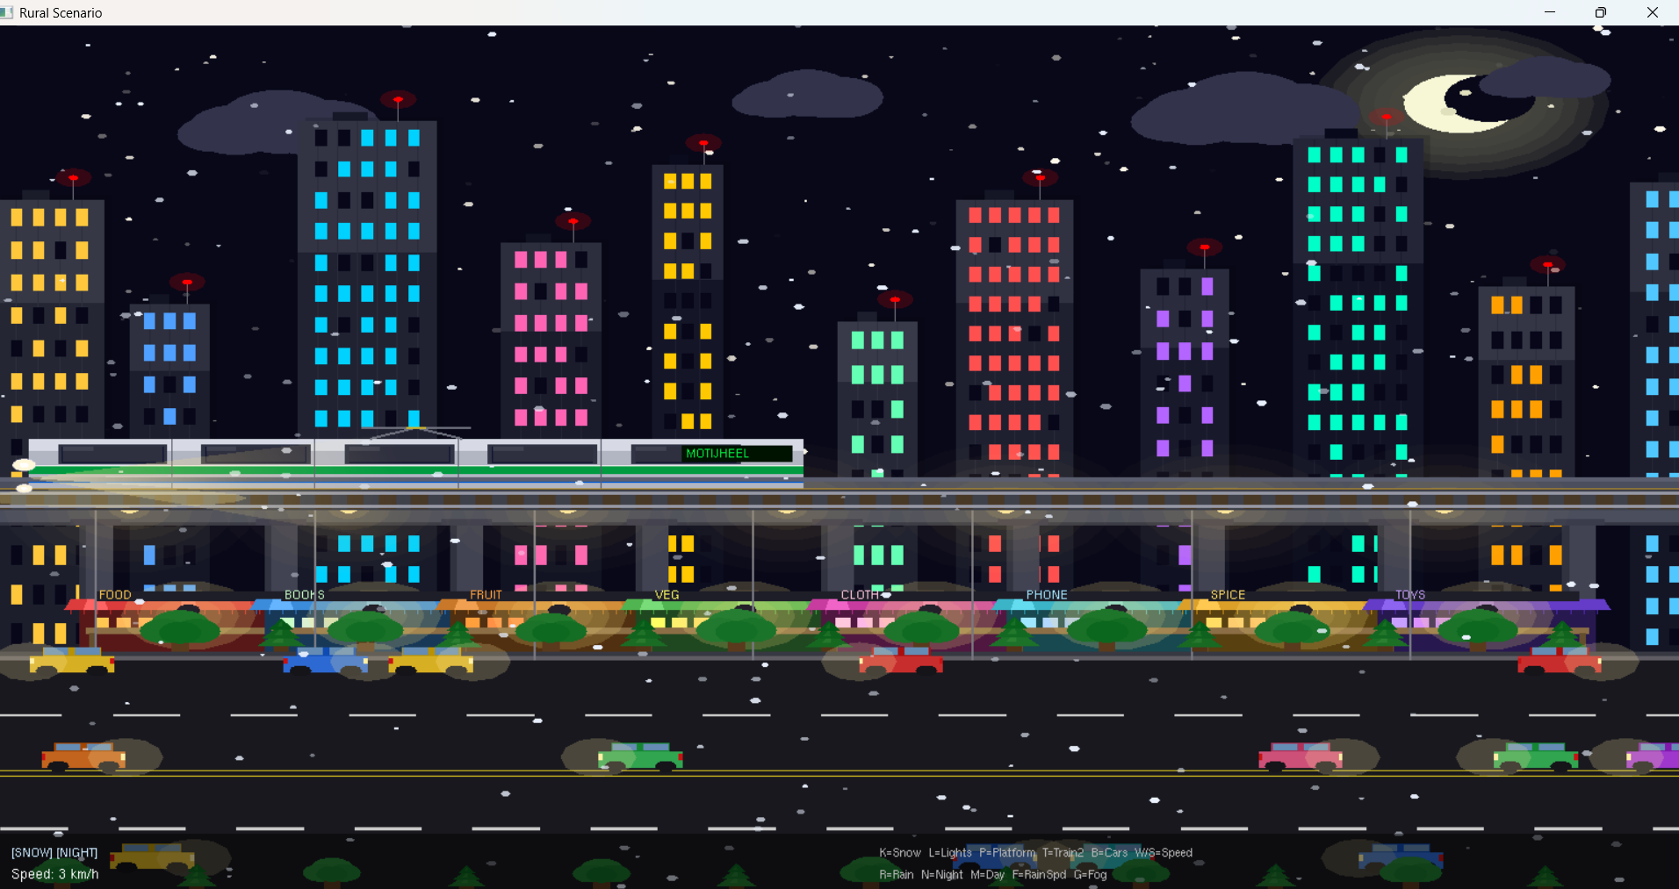
Fig 9: Metro Rail Town Output scenario with snow falling.

8. Result
The project successfully achieved all stated objectives. All three scenes render correctly at approximately 60 frames per second on a standard desktop with OpenGL support. Scene switching with X is instantaneous with no visual artifacts or state corruption between scenes. The traffic signal logic correctly stops cars at the stop line and allows already-crossing cars to pass. The weather system in Scene 0 is toggleable in real time without any performance drop. The ferris wheel in Scene 2 rotates smoothly with all cabins correctly positioned at spoke tips. Bird wing animation with per-bird phase offset produces a natural-looking flock.

9. Conclusion
This project demonstrates how OpenGL and GLUT can be used to construct rich, interactive 2D simulations in C++. Three types of transformations have been implemented in this project: translation, scaling, and rotation. These transformations are used to create realistic movement, positioning, resizing, and animation of different objects within the scenes. By encapsulating each scene into its own set of draw and update functions, and routing GLUT callbacks through a simple scene index, it was possible to combine three independent projects into a single cohesive application without any naming conflicts or shared state issues.
The work reinforced understanding of the OpenGL rendering pipeline, the importance of painter’s algorithm for correct layering, and techniques for achieving visual realism through alpha blending, gradient shading, and procedural geometry. The traffic signal logic, in particular, required careful mathematical reasoning about car positions and stop-line clamping to produce correct real-world behavior.

10. Limitation & Future Improvements
Limitations
- The project uses 2D OpenGL only; no depth testing or 3D perspective is applied.
- Window size is fixed at 1280×720; the coordinate system does not scale with window resize.
- Car-following logic uses a simple distance threshold, not a full physics-based model.
- Scene 1 day/night cycle is automatic and cannot be manually paused at a specific time.
- Collision detection between park humans is not implemented; they can overlap.
- No audio feedback is provided for events such as train arrival or traffic light change.

Future Improvements
- Add 3D perspective using OpenGL projection matrices and depth buffering.
- Implement a proper collision responsse system for park humans.
- Add sound effects using OpenAL or a simple Win32 audio API.
- Make the window resizable with a dynamic coordinate remapping function.
- Add a day/night slider or time-of-day system across all three scenes simultaneously.
- Introduce more vehicle types in the rural scene: rickshaws, buses, motorcycles.
- Add pedestrian figures walking on the metro platform in Scene 3.
- Implement a mini-map or scene-select UI overlay.

References
[1] OpenGL Programming Guide ("Red Book"), 8th Edition, Addison-Wesley, 2013.
[2] E. Angel and D. Shreiner, Interactive Computer Graphics: A Top-Down Approach with WebGL, 7th Edition, Pearson, 2014.
[3] FreeGLUT Documentation, https://freeglut.sourceforge.net/docs/api.php, accessed May 2026.
[4] OpenGL Reference Pages, https://www.opengl.org/sdk/docs/man/, accessed May 2026.
[5] Anthropic, "Claude AI Assistant," claude.ai, 2026. [AI tool used for code merging and logic fixing — conversation conducted May 2026].
[6] https://chatgpt.com/share/6a0bf883-a01c-8324-b0d4-6e15714c3ae6
[7] https://chatgpt.com/share/6a0bf8ba-c7f0-8321-9cb3-044a9ff70a05
[8] https://chatgpt.com/share/6a0bf8d3-8ef4-8320-84cc-d0010a417375

